|  |
| --- |
|  |

** NUST COLLEGE OF**

**PAKISTAN NAVY ENGINEERING COLLEGE**

**HOSPITAL MANAGEMENT SYSTEM**

A Web Enabled Electronic Medical Record and Reporting System

***Submitted by***

S/LT ALI RAZA PN

S/LT SHERULLAH PN

S/LT KHAWAR KHAN PN

S/LT ASADULLAH MEMON PN

**BACHELORS**

**IN**

**MANAGEMENT INFORMATION SYSTEM**

**YEAR**

**2014**

**PROJECT SUPERVISOR**

LT Yasir PN

|  |
| --- |
|  |

**PAKISTAN NAVY ENGINEERING COLLEGE**

**KARACHI**

**HOSPITAL MANAGEMENT SYSTEM**

A WEB ENABLED ELECTRONIC MEDICAL RECORD AND

REPORTING SYSTEM

***Submitted by***

S/LT ALI RAZA PN

S/LT SHERULLAH PN

S/LT KHAWAR KHAN PN

S/LT ASADULLAH MEMON PN

**BACHELORS**

**IN**

**MANAGEMENT INFORMATION SYSTEM**

**Year 2014**

**PROJECT SUPERVISOR**

LT YASIR PN

**DECLARATION**

We hereby declare that no portion of the work referred to in this Project Thesis has been submitted in support of an application for another degree or qualification of this of any other university or other institute of learning. If any act of plagiarism found, we are fully responsible for every disciplinary action taken against us depending upon the seriousness of the proven offence, even the cancellation of our degree.

**COPYRIGHT STATEMENT**

* Copyright in text of this thesis rests with the student author. Copies (by any process) either in full, or of extracts, may be made **only** in accordance with instructions given by the author and lodged in the Library of NUST College of PAKISTAN NAVY ENGINEERING COLLEGE. Details may be obtained by the Librarian. This page must form part of any such copies made. Further copies (by any process) of copies made in accordance with such instructions may not be made without the permission (in writing) of the author.
* The ownership of any intellectual property rights which may be described in this thesis is vested in PAKISTAN NAVY ENGINEERING COLLEGE, subject to any prior agreement to the contrary, and may not be made available for use by third parties without the written permission of the PAKISTAN NAVY ENGINEERING COLLEGE, which will prescribe the terms and conditions of any such agreement.
* Further information on the conditions under which disclosures and exploitation may take place is available from the Library of PAKISTAN NAVY ENGINEERING COLLEGE Karachi.



**ACKNOWLEDGEMENT**

We thank Allah Almighty for giving us strength and support to take this project and work on it. We express our gratitude especially to our supervisor Lt Yasir PN / Lt Tabinda PN for his constant support and encouragement throughout this project. He always encouraged us to do the best practices related to the work and has also given us the basic idea of the project. Also we wish to thank our parents, group mates for hard work, brother and sisters for their prayers and wishes.

**ABSTRACT**

New applications such as Data warehousing and software applications such as data mining and advancement in decision support systems have made it possible to access and analyze large stores of data. Combined with new system methodologies such as rapid application development (RAD), it is quicker to develop information systems. As a consequence we are seeing advancement in health-care computing moving more and more towards electronic medical records, e-businesses and e-health applications. The idea of paper less Electronic Medical Records has been an emerging one paper records of patients are scattered across various practitioners and doctor without having previous medical history of patient have sometime no idea what to do. In America only 98,000 deaths occur annually due to medical mistakes and 1.5 million people suffer from drug infections, incorrect doses and other medical errors. In this scenario, there should be system which promotes the concept of paperless working inside hospitals. HMS can reduce the medical cost considerably and can help the organizations providing the medical allowances to decide about an employer for medical funds.

Our Project **HMS** is a facilitating system for hospital staff and patients to have an online portal for managing their information by integrating different departments of the clinic or hospital online. It will enable the Doctors, Patients, Clinics and Labs to register online and starting using the Practice management system within a no cost. The system will provide mobility to the patient records and will allow doctors and hospital administration to work anywhere by just logging on to their account and they need not have to develop software and maintain it. In this way, their software development, installation and maintenance cost is saved. Once registered, the user-id and login will be allotted to the user through SMS.

**TABLE OF CONTENTS**

Declaration ………………………………………………………………………………….………..3

Copy Right Statement ……………………………………………………………………….……… 4

Acknowledgement …………………………………………………………………………..……… 5 Abstract …………………………………………………………………………………………...….6 Table of Contents ………………………………………………………………………………. …..7

List of Figures………………………………………………………………………………………..9

List of Tables………………………………………………………………………………………..10

Chapters Index ……………………………………………………………………………..……….13

1. Chapter ONE: Introduction ___________________________________________________13
   1. Overview ………………………………………………………………………………13
   2. Motivation …………………………………………………………………………….14
   3. Objectives of the System ……………………………………………………………..14
   4. Methodology …………………………………………………………………………..15
   5. Project Scope …………………………………………………………………………..15
   6. Project in Brief …………………………………………………………………………16
2. Chapter TWO: Literature Review _____________________________________________ 18
   1. An Introduction to Scripting Languages ……………………………………………… 18 what are Scripting Languages? …………………………………………………………………..18
   2. Overview of different scripting languages …………………………………….……....18 PHP ………………………………………………………………………………………………18 - ASP.net ………………………………………………………………………………………... 19

Cold Fusion ………………………………………………………………………………….. …19 - Python ……………………………………………………………………………………….. ..20 - RUBY ……………………………………………………………………………………….. …20

1. Chapter THREE: Methodology and Implementation _____________________________21
   1. Project Planning ……………………………………………………………………….22
   2. Software Requirement Gathering ……………………………………………………. 22
   3. Design ………………………………………………………………………………… 24 - Data Modeling …………………………………………………………………… ……………. 24
   4. High Level Design …………………………………………………………………… 22

- High Level Design ……………………………………………………………………..............26

Portals………………………………………………………………………………………………26

Detailed Design…………………………………………………………………………………….26

1. Graphical User Interface (GUI) and Software Usage ___________________­­__________ 28

­­

Main Page ………………………………………………………………………….………….. ...28

Reception Page………………………………………………………….………………….……..29 Online Survey……….……………………………………………………………………………30 Patients…. ……………………………………………………………………………………….. 31

Pricing page …………………………………….…………………………………………………..32 Inventory page ……………………………………………………………………………………... 33

Admin……. ………………………………………………………………………………………. 34

Contact us ……………………………………………………………………………………..…..35

1. Chapter FIVE: Summary and Limitation _________________________________________ 36
   1. Summary ……………………………………………………………………………… 36
   2. Limitations ……………………………………………………………………………. 37
2. Chapter SIX: Conclusion and Future Work _______________________________________ 39
   1. Future Work ………………………………………………………………………….. .39
   2. Conclusion ……………………………………………………………………………...40
3. References ___________________________________________________________41

**LIST OF FIGURES**

Figure 1: HMS Scope…………………………………………………………………15

Figure 2: RAD (Rapid Application Development Model)……………………...21

Figure 3: Project Planning……………………………………………………………22

Figure 4: Database Development Process…………………………………………….24

Figure 5: Data Modeling……………………………………………………………...25

Figure 5: Main Page…………………………………………………………………..28

Figure 6: Reception Portal……………………………………………………………29

Figure 7: Online Survey……………………………………………………………....30

Figure 8: Patients Portal……………………………………………………………….31

Figure 9: Pricing……………………………………………………………………….32

Figure 10: Inventory…………………………………………………………………...33

Figure 11: Admin………………………………………………………………………34

Figure 12: Contact us…………………………………………………………………..35

**LIST OF TABLES**

Table 1.7 High Level Project Pl.....................................................................................................17

Table 3.2 Roles in Software Development……………………………………………………...23

**CHAPTERS INDEX**

Chapter ONE: Introduction Overview

Motivation

Objectives of the System

Methodology

Project Scope

Project in Brief

Chapter TWO: Literature Review

An Introduction to Scripting Languages

What are Scripting Languages?

Overview of different scripting languages

* PHP
* ASP.net
* Cold Fusion
* Python
* RUBY

Chapter THREE: Methodology and Implementation

Project Planning

Software Requirement Gathering

High Level Design

Detailed Design

Object Relational Mapping (ORM)

Chapter Four: Graphical User Interface (GUI) and Software Usage

* Main Page
* Reception Page
* Online Survey
* Customers
* Pricing Page
* Inventory Page
* Admin Page
* Contact us Page

Chapter FIVE: Summary and Limitations

* + 1. Summary
    2. Limitations

Chapter SIX: Conclusion and Future Work

1. Future Work …………………………………………………………………………..
2. Conclusion ……………………………………………………………………………

SEVEN: References

CHAPTER ONE



**INTRODUCTION**

**1.1 Overview**

Web Application is an application that is invoked in a web browser over the internet. Since the launch of internet, it has become the launching pad for many sophisticated and innovative web applications. Previously it was used mostly for accessing static websites but now dynamic applications are in common. New web technologies, standards and programming languages have enabled to create dynamic web applications that create co-operation and collaboration among large number of users. Web application development is quick to adopt the software engineering techniques. Web application development is made easy with the help of **open source software** often termed as **frameworks.** These frameworks allow **rapid application development** by allowing development team to focus on the features of theirapplication that they are providing to the user without worrying about other details such as user management. Examples of web applications are simple office applications such as word processors, spreadsheets and online presentation tools. But more advanced applications are also present such as point of sales software, picture editing and drafting tools.

The modern era has become very advanced and well-developed and the basic reason for this is the internet and the applications which have been launched with the help of internet e.g. internet banking and money transfer, e-commerce etc. The internet has totally changed the way many people accomplish their tasks turning them into modern and latest lifestyle with its developments. The modern development in internet has widened the opportunities for business and professional development. Maximum effect of internet is on an individual’s life. The management system ranging from a large industry to a small sales point is getting computerized and more preferably web enabled if the access to internet is easy and economical. Systems are going from manual to computerize thus reducing the paper work because it is very difficult to search for information and to manage records manually. It needs time and extra labor but computerized management and information portals are handling the activities very efficiently and they can even be customized according to the needs of a specific user.

The management and information systems for a company or an institution etc are mostly developed and installed on individual systems or they are running on local intranet which is only accessible within the institution or organization. The Internet has brought about the various communication means and the application packages over the internet which are making a clear way towards making **software as a service** over the web, considerably reducing the software development andmaintenance cost which was not easy to afford for many small scale business vendors. Now with the increasing demand of data storage capabilities, different vendors are providing cloud services for efficiently storing the data for any need. This has become possible because of rapid development in communication technology and internet speed. Storage of data over internet is in fact the most reliable because it enables easy recovery of data in case of any lose or damage.

Although there is security concerns over internet due to hacking techniques but the advantages of this technology overweigh some of the disadvantages.

This technology can bring revolutionary changes when applied to the medical field concerning handling of Hospital Management System online. Although running software across internet is not a big deal, some major service providers are providing their services over a decade but use of software in medical technology is still lacking behind especially in our country.

Our project **HMS** (Web enabled Electronic Medical record and Transcription Management System) is a web-based solution that has no software to download or no hardware to purchase. Just a matter of seconds, patient, doctors and admin can sign up and start using the web services to enter access and update patient records. We no more need a permanent IT consultant at the hospital for maintaining a local intranet. The main aim is to reduce the paper work and go online for data storage and retrieval. It is possibly easier transition to different system and easy to setup hot-site in case of disaster.

**1.2 Motivation**

Much of the systems for Practice management today are working on the local intranet and there is very less mobility of Patient Medical Record. Patient has to consult the particular physician for attaining his/her medical history which is crucial especially in case of Emergency. Patient history maintained at one place is more comprehensive including previous medication and allergies if any.

Medical Practice Management and reporting systems running on local intranet have less privileges and information transfer between different departments is slow and scattered. Providing Software as a Service (SaaS) online can facilitate doctors, hospitals and labs to reduce their software development, deployment, installation and maintenance cost considerably which may result in low cost billing. Nowadays especially in Pakistan most of the physicians are keeping their records in files managed by extra staff that is burden on the physician.

Clinic management tools and services once deployed and installed are very difficult to re-install and changing is very critical. The data managed by these tools require a lot of care and there can be huge loss of information in case of database failure.

Data managed online is independent of the particular system using the software. Rather changes are developed and adopted by system as suggested by users and implemented by administrators without need to change the underlying platform.

**1.3 Objectives of the System**

* Providing **practice management system** to be used as a software as a service
* **Paper less Electronic medical records** of patients that are easily accessible by physicians andpatient. Doctors, patients and staff can logon remotely to access their data.
* **Scheduling:** Bridging gap between different hospitals and patients and online appointmentbooking. Doctor can see his day to day activities and appointments.
* Giving the real time Patient Access to their online medical records from anywhere in the world
* **E-Prescribing** is best done when a patient is encountered. Viewing the complete history of thepatient at one place allows the physician to take better decision for medication. The Prescription would be directly emailed to the Pharmacy or printed out and handed over to the patient.
* Consideration of even most minor findings during medical check-up of a patient

- Eliminating the need for patients to take care of their reports and prescription

**1.4 Project Methodology**

* Any software product starts with the requirement gathering from stack holders. So we visited different clinics including PNS SHIFA and PNS RAHAT to meet the doctors and analyze their information systems. To learn what is running and how it can be improved. We consulted internet for recent developments in this field and to see how many systems are currently providing this web facility.
* As far as development is concerned, we adopted PHP as server side language. Web pages were designed using HTML, CSS, Java-Script and jQuery library.
* There are eight main portals. They are Home, Reception, Online survey, Customers, Pricing, Inventory, Admin and Contact us portals. Doctor portal and Patient portal is within the clinic portal.

**1.5 Project Scope**

* HMS is intended to provide medical services to small or medium sized clinics and hospitals for practice management and online scheduling.
* It consists of Patient, Admin, Doctor, Clinic and Lab Portal for managing day to day activities
* Data recorded by web app may used further for data mining and other statistical analysis

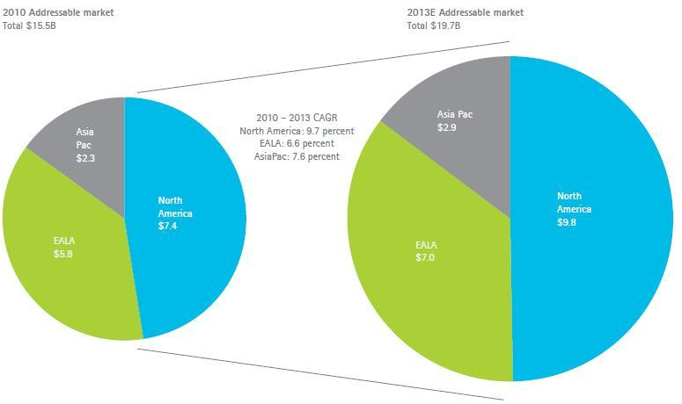

Figure 1: HMS Scope

**1.6 Project In Brief**

**Project Title:** HMS

**Project Start:** December 2012

**Project Finish:** May 2014

**Project Summary:**

**HMS** is a web based Medical Prescription and Record Management System. An online database management system for patient records allows doctors to enter, retrieve and perform analysis on medical data and also to generate reports and prescriptions within no time. In case a patient losses his/her medical history, it is easily be retrieved through web. It decreases the doctor and lab attendant’s turn-around time. More over it is mined for different patterns of information relating to specific diseases and its treatment. In short, HMS is a software solution that attempts to take Health Information Management into the digital age.

**Software Platforms/Languages:**

PHP, HTML, CSS, Java script, jQuery, WAMP Server.

**Integrated Development Environments:**

MYSQL Work Bench (For Database Modeling and Schema and to be used as Database Server) Sublime Text Editor

**Hardware:**

No hardware has been used yet for development

**Project Supervisors:**

Lt Yasir PN / Lt Tbinda PN

|  |  |  |  |  |  |  |  |
| --- | --- | --- | --- | --- | --- | --- | --- |
|  | **1.7 High Level Project Plan** | | | | | | |
|  |  |  |  |  |  | |
| Activities/Milestones |  |  |  |  | Date | |
|  |  |  |  |  |  | |
|  |  |  |  |  |  | | |
| Proposal Submission |  |  |  |  | September 2011 | |
|  |  |  |  |  |  | |
|  |  |  |  |  |  | | |
| Proposal Approval |  |  |  |  | January 2012 | |
|  |  |  |  |  |  | |
|  |  |  |  |  |  | | |
| Requirement Specification |  |  |  |  | May 2012 to July 2012 | |
|  |  |  |  |  |  | |
|  |  |  |  |  |  | | |
| Higher Level Design |  |  |  |  | February 2013 | |
|  |  |  |  |  |  | |
|  |  |  |  |  |  | | |
| Problem Classification Design |  |  |  |  | End of November / 3rd week of December | |
|  |  |  |  |  |  | |
|  |  |  |  |  |  | | |
| Development/ Prototyping |  |  |  |  | January 01, 2014 on wards |
| Table 1.7 High Level Project Plan |  |  |  |  |  |

CHAPTER 2



**LITERATURE REVIEW**

1. **An Introduction to the Scripting Languages**
2. *What is a scripting Language*

A Scripting language is such a language which is used in conjunction with other programming languages such as Java, C++ or HTML etc and normally run inside a web browser. There are both client side and server side scripting languages. Some of the most widely used scripting languages are Perl, Python, PHP, VBScript, ASP.net, JavaScript, Ruby on Rails.

**Client side scripting** languages are those in which scripts execute in browser on user side. E.g.Java Script, Visual Basic. Client side programming is almost done with Java script in addition with HTML and CSS.

**Server Side Scripting** languages are those in which scripts execute on server side on Applicationservers. E.g. PHP, Python, Ruby. Server side scripts run the HTML page is loaded and not after.

**2.2 Comparison of different Scripting Languages**

1. ***PHP***

PHP is one of the most widely used scripting languages and it freely available. Many popular

websites are built in PHP. It has an extensive API documentation.

Its code is as follows: -

|  |  |  |  |  |  |  |  |  |  |  |
| --- | --- | --- | --- | --- | --- | --- | --- | --- | --- | --- |
| <html> | | | |  |  |  |  |  |  |  |
| <head> | | | |  |  |  |  |  |  |  |
| <title>PHP | | | | | | Hello |  | World | Demo</title> |  |
| </head> | | | | |  |  |  |  |  |  |
| <body> | | | |  | |  |  |  |  |  |
|  |  |  |  | | |  |  |  |  |  |
| <?php | | |  | | |  |  |  |  |  |
|  |  |  |  |  |  | $greeting | = | "Hello | World!"; |  |
|  |  |  |  |  |  |  | Echo |  | $greeting; |  |
| ?> | |  |  |  |  |  |  |  |  |  |
|  |  | | | | |  |  |  |  |  |
| </body> | | | | |  |  |  |  |  |  |
| </html> | | | | | |  |  |  |  |  |

* PHP is easy to learn for previous C programmers.
* It is server side language.
* It is an open source language.
* Object oriented programming language.

1. ***ASP.net***

As shown from name, ASP is supplied with .net framework by Microsoft and it is easy to learn scripting language.

1. <html>
2. <head>
3. <title>ASP.NET Hello World Demo</title>
4. </head>
5. <body>

6.

7. <% Response. Write ("Hello World!") %>

8.

1. </body>
2. </html>

ASP.net is popular on Windows based hosting packages.

1. ***Cold Fusion***

Cold Fusion is used by many enterprise level web application frameworks. The plus point is that it can easily be integrated with adobe frameworks such as FLEX and AIR. A sample application in Cold Fusion may look like this:-

|  |  |  |  |  |  |  |  |  |  |
| --- | --- | --- | --- | --- | --- | --- | --- | --- | --- |
| <html> | |  |  |  |  |  |  |  |  |
| <head> | |  |  |  |  |  |  |  |  |
| <title>ColdFusion | | | |  | Hello |  | World | Demo</title> |  |
| </head> | | |  |  |  |  |  |  |  |
| <body> | |  | |  |  |  |  |  |  |
|  |  | | |  |  |  |  |  | |
| <cfset | | | | var | Greeting | = | "Hello | World"> |  |

<cfoutput>#greeting#</cfoutput>

</body>

</html>

Ruby is more productive then Cold Fusion. Rail is effectively a DSL (Domain Specific Language) that targets database-driven web site development. Ruby's flexible syntax allows Rails to appear like its own language, with the full power of a dynamic OO language under the hood .

1. ***Python***

Python is a general purpose scripting language used for developing web applications. It is simple in syntax and has rich text manipulation functionality. It is stronger Object Oriented Language than PHP. It is similar to PHP and simple in syntax.

As compared with Ruby, both languages are dynamically typed, interpreted, scripting and simple to learn. There is a lack in Python that indentation is very important and sometimes irritating for the programmer. Python is although more mature language as for as programming is concerned but Ruby handles databases more efficiently. It has a lot of collection of gems (packages in Ruby) freely available at www.rubygems.org for use which enhance its functionality.

**2.2.5 Ruby**

Ruby is an object oriented interpreted programming language. Ruby on rails (framework) rapidly become one of the useful framework for the development of the dynamics websites. we also select ruby on rails for our project because it has many advantage first advantage is that it is 100% open source its tutorial are available on net and its cost nothing to download or use many companies use ruby on rails for the development of websites. Rails also owe much of the success to its elegant and compact design.

Rails were introduced in 2003 by David Heinemeier and were open sourced in 2004. Rails took Ruby to the heights. Ruby was the first frame work to fully digest and implement the rest architectural style for web application structure.

Chapter Three



**METHODOLOGY AND IMPLEMENTATION**

Every software Project normally contains following steps:-

1. **Project Planning and Proposal Writing**
2. **Software Requirement Gathering**
3. **Design**
4. **Development**
5. **Integration and Testing**
6. **Installation and Deployment**

These steps are simple and straight forward and there is risk in case of failure. So Rapid Application Development (RAD) architecture for software development was introduced. Schematic of this process is shown in figure below:-

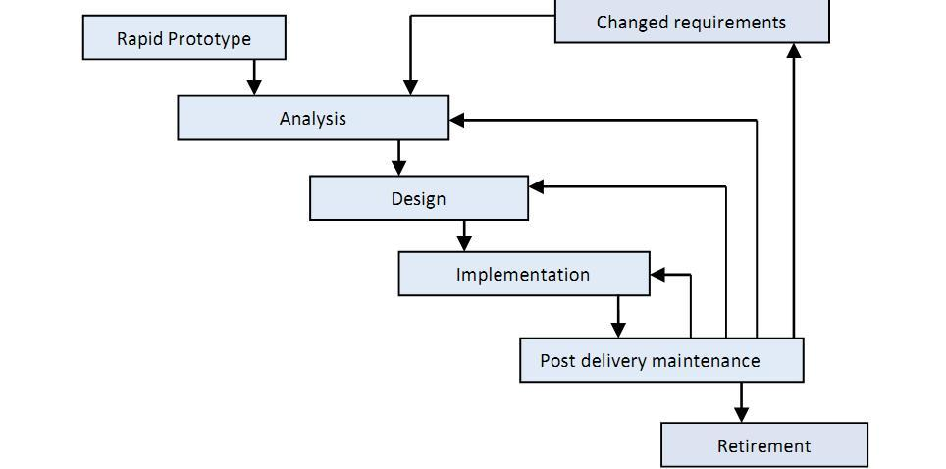

Figure 2: RAD (Rapid Application Development Model)

It is clear from the figure that it is an incremental process of development. Rails Framework also follows this process for development.

**3.1 Project Planning**

Project Planning is the part of Project Management which relates to the use of schedules such as Gantt charts and timeline to demonstrate starting and ending date within the project environment. The proposed web application was intended to be launched as Software as a Service to facilitate the Doctors and patients maintaining their data.

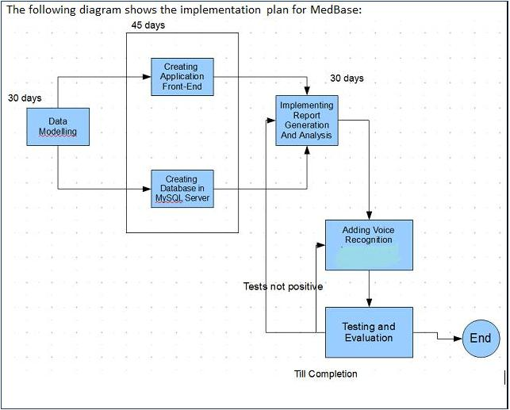Following diagram shows our basic planning of the project:-

Figure 3: Project Planning

The need for software and hardware platform was determined. Plan was made for efficient communication of group members over social network or weekly meetings to synchronize the work throughout the development phase.

At the end, the following initiatives were planned and consulted with the supervisor:-

* + Implementation should start with Database Modeling that will be as generic as possible
  + Web Application should be developed using a modern technology new for development and good for learning purposes
  + There should be weekly meeting among group members for project initiation

1. **Software Requirements**

Software requirements is the complete description of the software how the software works and its contains use cases which described how the software interact with the user. Before development of the software we collect all functional and non function al requirements from the user because user is the best person who tells about the whole problems and requirements which are necessary in the

software. The software requirements specification document enlists all necessary requirements that are required for the project development. To derive the requirements we need to have clear and thorough understanding of the products to be developed. This is prepared after detailed communications with the project team and customer. We decided to make a online hospital management system for hospitals and clinics. Our software users are doctors patients and staff working in the hospital and also clinic manager. For the sack of different information about our software we visit different hospital and clinics and with different doctors and patients.

* We visited different clinics and doctors to gather the initial requirements including:-
* PNS SHIFA Karachi
* PNS RAHAT Karachi
* At PNS SHIFA we saw that the information was gathered at local intranet which was dumped onto local server. The pattern of information was not well structured. Record was maintained on files. Moreover, paper records were also present for each patient and searching for a particular record took a lot of time.
* On the basis of our project requirements we divided our work between group mates and stared work on our project. these are the main reasons of for collecting of requirements specifications .

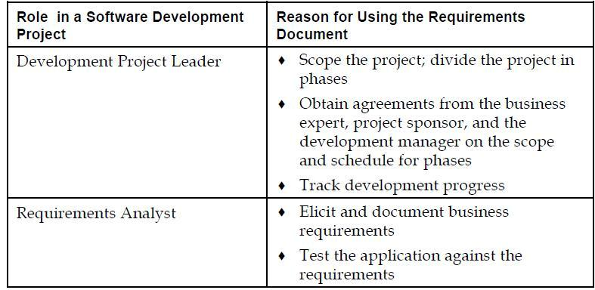

Table 3.2 Roles in Software Development

Stake Holders in the Project:-

PROJECT SUPERVISOR: Lt Yasir PN / Lt Tabinda PN

* Development Project Leader: S/Lt Asadullah Memon PN
* Requirement Analyst: S/Lt Ali Raza PN
* Front End Developer: S/Lt Sherullah PN
* Back End Developer: S/Lt Khawar Khan PN

**3.3 Design**

1. *Database Development Life Cycle*

First step in designing our application was database design. It was intended to be very strong and powerful and generic because it has to map onto different clinics and hospitals. Normally **Waterfall method** is used as the basis of the database development process.

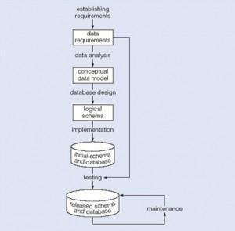

Figure 4: Database Development Process

1. *Data Modeling*

The process of data modeling starts with the selection of the main entities that will play role in

the organization. We developed a basic Entity-Relationship Diagram as shown in the figure on the following page.

The Blocks in the diagram represent a “Relation” or an “Entity” in the database whereas lines containing connectors show relationship among them. This is the part of Conceptual Database Design used to map the structure of database for our application.

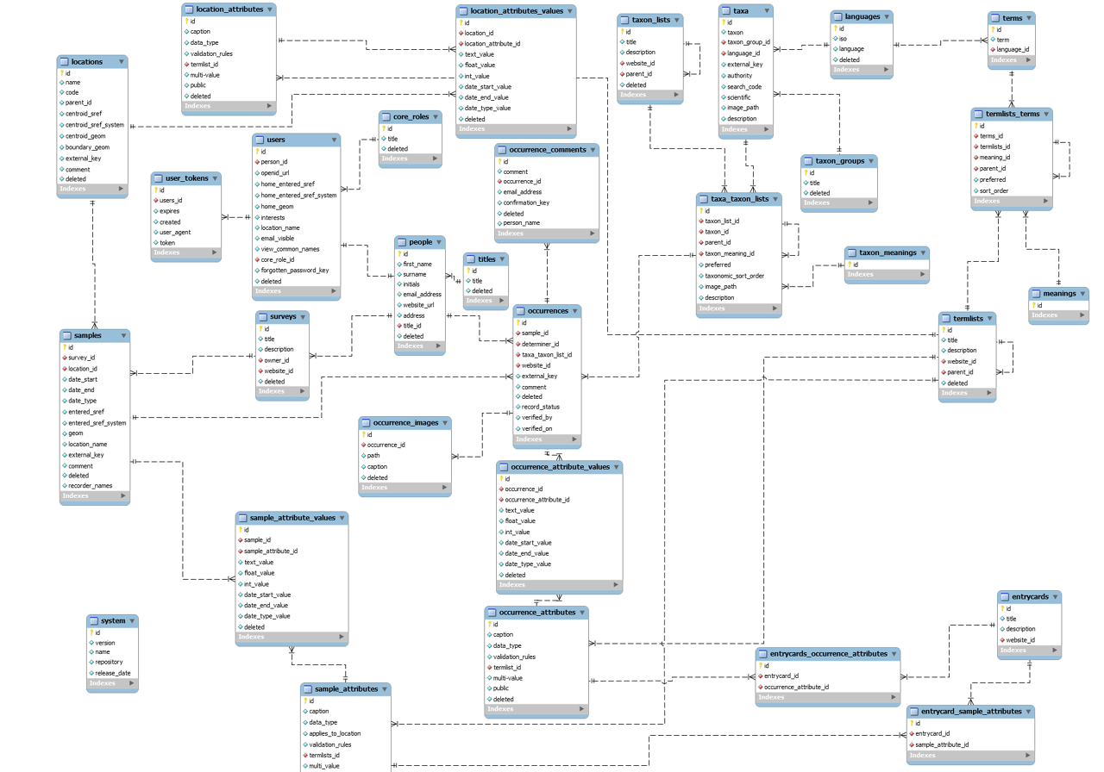



Figure 5: Data Modeling

**3.4 High Level Design**

The Web pages are designed in HTML, Java Script, CSS and PHP. HTML describes the basic layout of the page as girders set the layout of ceilings. Then CSS is for enhancement of color, pop-ups etc. Java Script is used for Client side data verification and Ruby for the remaining back-end coding.

* + 1. ***Portals***

There are eight main portals of our app yet. They are:-

* Home Portal
* Reception Portal

* Online Survey Portal
* Patients Portal
* Pricing Portal
* Inventory Portal
* Admin Portal
* Contact us Portal

* 1. **Detailed Design**

*3.5.1 Requirement Gathering*

Visits to different doctors and clinics were conducted. Moreover, when we participated in different exhibitions like SOFTEC in Lahore held on 20th April 2013, the suggestions of critics helped us to mould our requirements and database design. We also searched on internet for different database design strategies.

* + 1. *Data Modeling of a Clinic*

The Conceptual schema of the database was created in MySQL and then it was forward engineered to create actual logical schema of the database.

* + 1. *Forward Engineer*

Once the model is defined in software; In MYSQL IDE, Forward Engineer option is available for translating the schema into tables.

*3.5.4Object Relational Mapping (ORM)*

The powerful migration tool of PHP, helps to migrate the databases in other DBMS to PHP language.

Chapter Four



**GRAPHICAL USER INTERFACE AND SOFTWARE USAGE**

There are EIGHT portals developed so far and we are increasing our functionality each day.

**4.1 Main page:**

Main page is the front view of our project HMS. On main page all the portals are available by which a customer can access his/her required portal.

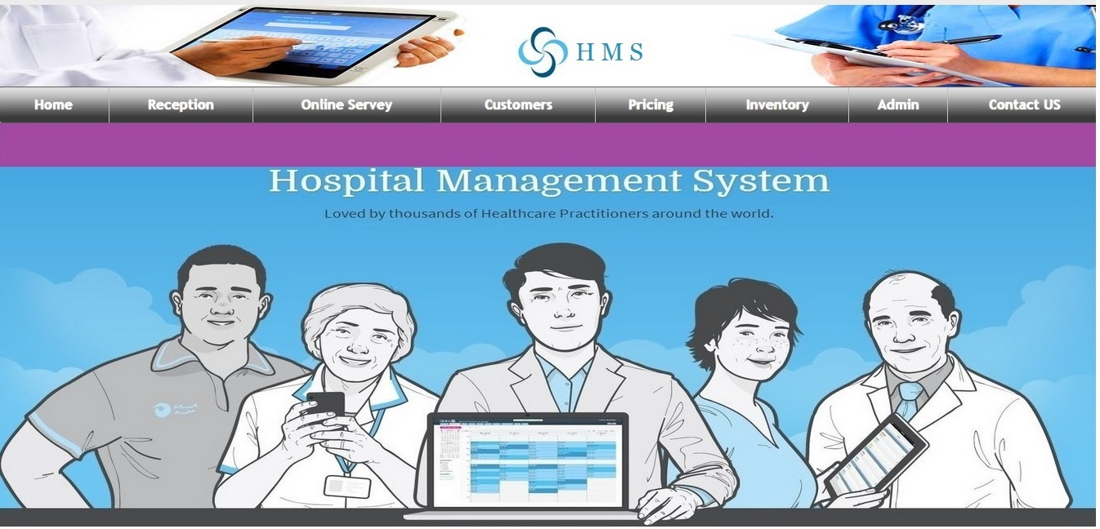

Figure 5: Main Page

**Reception portal**

**4.2 Reception Page**

In reception page patient can log on with his / her assigned id and password and can get medical treatment online or can have appoint with his / her concern doctor by clicking on button “ For Patient”. New patients can also get themselves registered by clicking on “sign up”.

Same goes for doctor, he can also log on through same page and can check his / her appointments for that day by clicking on button “For Patient” and also can check records.

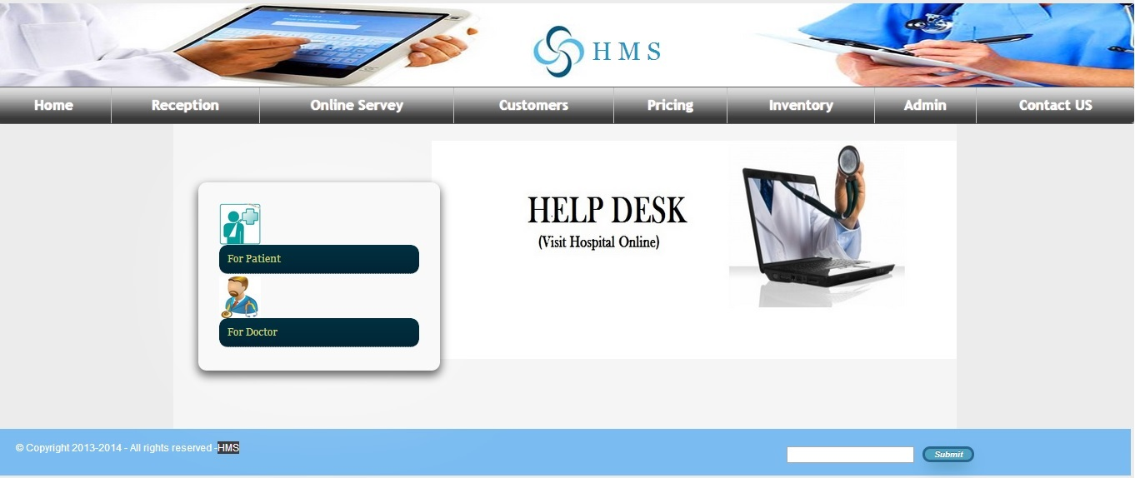

Figure 6: Reception Portal

**4.3** **Online Survey**

The Online Medical Treatment System brings the solution of your problem on single click. This provides vital details of every disease and its treatment as well. A patient sitting at home can get the awareness regarding any disease online. Diseases are numbered alphabetically form A-Z.

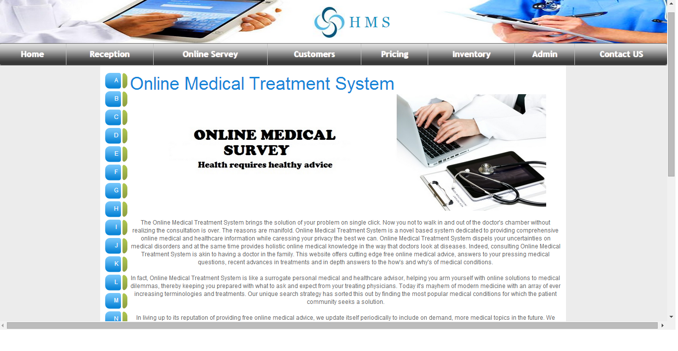

Figure 7: Online Survey

**4.4 Patients Portal:**

This portal shows some of our happy customers who are benefited from HMS. Their comments are also shown under their picture. The purpose of this portal is online advertisement of HMS.

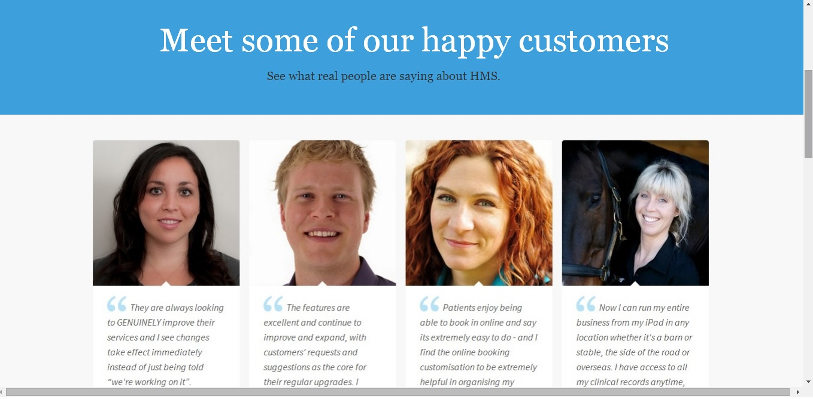

Figure 8: Patients Portal

**4.5 Pricing:**

This picture shows the pricing criteria for civil and military personnel in USD ($).

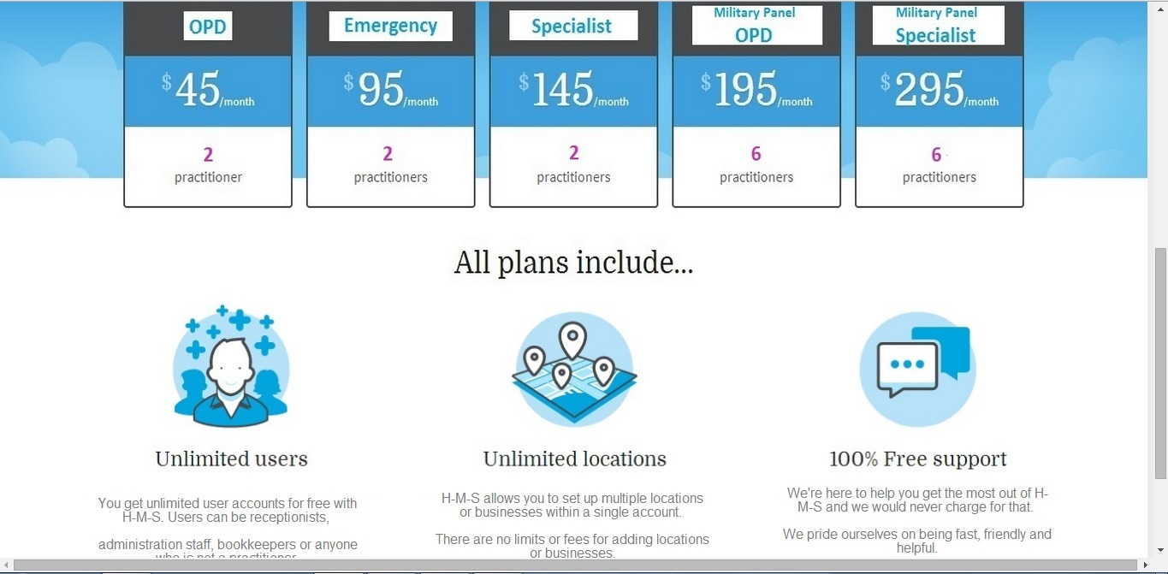

Figure 9: Pricing

**4.6 Inventory**

This is the inventory portal through which inventory management and control is carried out. Inventory can be checked by putting name of said inventory or by inventory ID.

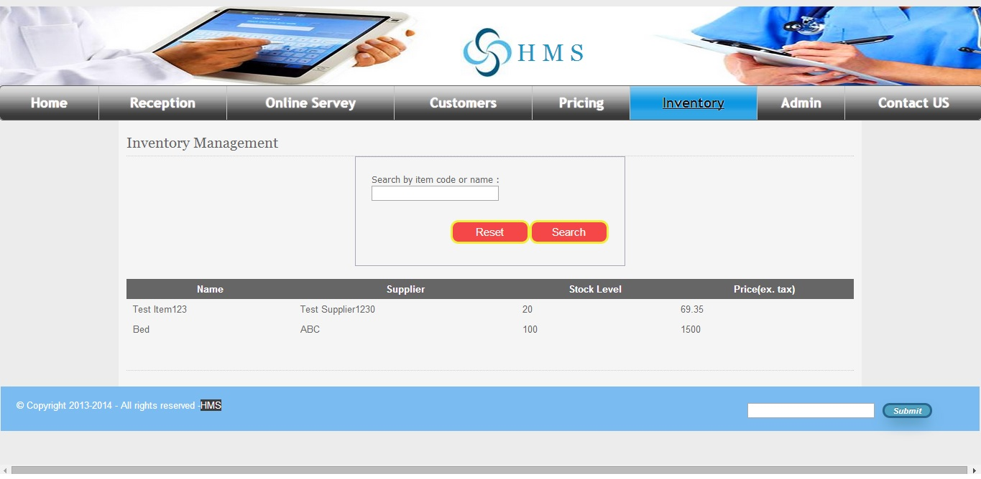

Figure 10: Inventory

**4.7 Admin**

Admin can access record of doctor, patient, it has passwords of doctors and patient without permission of admin we cannot access data. If admin enable then doctors and patients can do practice through HMS .HMS is portal hospital management system control through server. Data manage through server no need to install in every system only internet connection is necessary required.

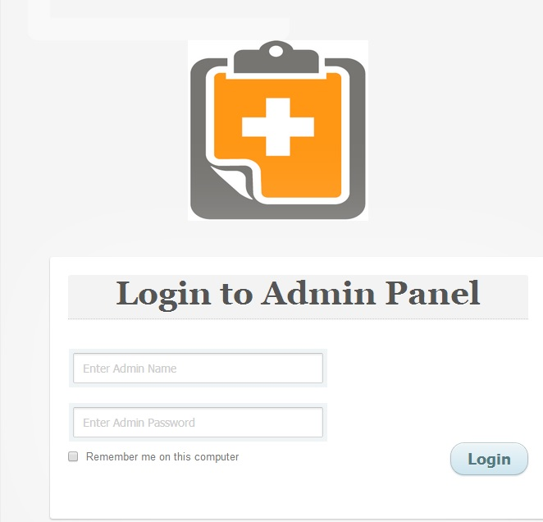

Figure 11: Admin

**4.8 Contact us**

Through “Contact us” portal patients can contact us by giving some information in given columns which includes name, email address, web URL, phone number is optional, if phone number is added then through sms we contact our patients. More over patients can have treatment through email facility.

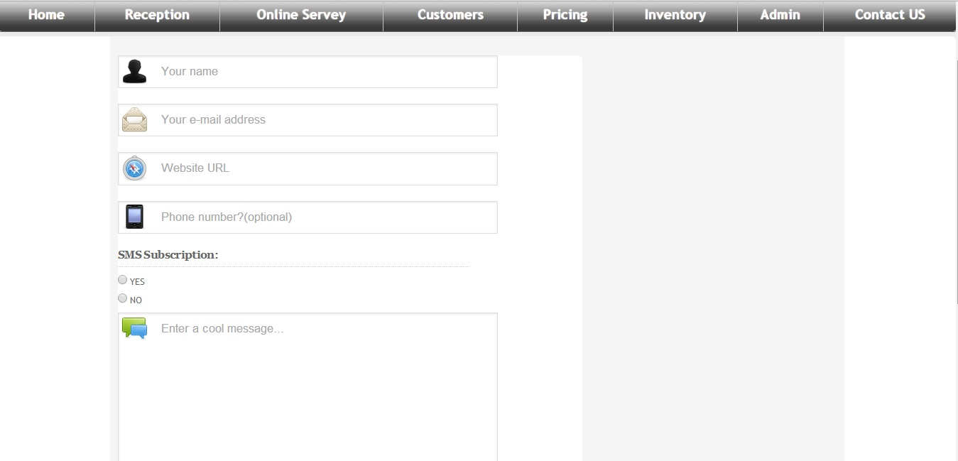

Figure 12: Contact us

Chapter Five



**SUMMARY AND LIMITATIONS**

**5.1 Summary**

**HMS** is a web based Medical Prescription and Record (EMRs) Management System. An online database management system for patient records allows doctors to enter, retrieve and perform analysis on medical data and also to generate reports and prescriptions within no time. In case a patient losses his/her medical history, it is easily be retrieved through web. It decreases the doctor and lab attendant’s turn-around time. In the long run, such a data bank could be mined for different patterns of information relating to specific diseases. In short, HMS is a software solution that attempts to take Health Information Management into the digital age.

Our Project **HMS** is a facilitating system for hospital staff and patients to have an online portal for managing their information by integrating different departments of the clinic or hospital online. It will enable the Doctors and Patients to register online and starting using the Practice management system within a no cost (during trial period) or low cost (after trial expiry). The system will provide mobility to the patient records and will allow doctors and clinics/hospital administration to work anywhere by just logging on to their account and they need not have to develop software and maintain it. In this way, their software development, installation and maintenance cost is saved. Once registered, the user-id and password will be allotted to the user through SMS. HMS also provides information regarding different diseases and its treatment at each visit, patient prescription. Patients can also book appointments by contacting online to the doctor.

The management and information systems for a company or an institution etc are mostly developed and installed on individual systems or they are running on local intranet which is only accessible within the institution or organization. The Internet has brought about the various communication means and the application packages over the internet which are making a clear way towards making **software as a service** over the web, considerably reducing the software development andmaintenance cost which was not easy to afford for many small scale business vendors. Now with the increasing demand of data storage capabilities, different vendors are providing cloud services for efficiently storing the data for any need. This has become possible because of rapid development in communication technology and internet speed. Storage of data over internet is in fact the most reliable because it enables easy recovery of data in case of any lose or damage. Although there is security concerns over internet due to hacking techniques but the advantages of this technology overweigh some of the disadvantages.

**5.2 Limitations**

Every software project has some milestones and targets. Some are achieved and some remain intact due to lack of time and resources. We too had a lot of goals and milestones but we are on the way to achieve few of them although we have achieved 60% to 70% target. Only a few are left behind due to lack of time which is 4-5 months and funding which was needed to accomplish.

Some of the limitations we have faced are as below:-

* **Voice Enabled Prescription Management:** Accessing different record fields throughmicrophone and calling different commands detected by system thus saving doctor’s time considerably.

The task to accomplish was not so easy because there are only a few websites across the world that allows this functionality on the web due to the following reasons:-

* + There is a lack of standards for speech on the web
  + Web pages are likely to have responsive design these days so this functionality is very less in use due to lack of responsiveness of pages
  + In Pakistan there is hardly anyone working on this area of telemedicine so it was a unique idea
* **Pharmacy Control:** Sending of Prescription online to pharmacy so that they can giveappropriate dosage, Pharmacy inventory, staff payroll. The patient should not need to wait more in the pharmacy just he has to speak out his number and it will display the prescription in front of pharmacist (that will be linked to concerned clinic).
* **Intelligent Reporting System:** Combined with voice enabling functionality providing severaluseful reporting views to the software user. Currently we are on the way of finishing the reporting. This reporting will be a unique feature of our project as other vendors in the market are not providing this service yet. It will help doctors to promote the idea of “Prevention is better than cure”.
* **Lab Assistance System:** A sub module for assisting the labs for conducting tests.
* **HR Management & Payroll:** Employee history, daily attendance, scheduling, pay slip, salarysheet and over time summary. The system will provide ERP system over the web to control and monitor the Finance related matters.
* **Financial Accounting:** Integrated with pharmacy control, HR management and payrollproviding patient billing details, balance sheet, and employee profile.
* An active **Data Warehouse** functionality which prepares data ready to be used for Data Mining and other statistical analysis. We have discussed this in intelligent reporting system.
* There is more need to customize the project and make it more general according to the need of the users as they desire. **(Customization)**

Chapter SIX



**FUTURE WORK AND CONCLUSION**

**6.1 Future Work**

As we have already discussed that the scope of the project is very broad and it can be extended to several dimensions. Our forecast is shown below: -

- **Voice Enabled Prescription Management:** Accessing different record fields through microphone and calling different commands detected by system thus saving doctor’s time considerably.

The task to accomplish was not so easy because there are only a few websites across the world that allows this functionality on the web due to the following reasons:-

* + There is a lack of standards for speech on the web
  + Web pages are likely to have responsive design these days so this functionality is very less in use due to lack of responsiveness of pages
  + In Pakistan there is hardly anyone working on this area of telemedicine so it was a unique idea
* **Pharmacy Control:** Sending of Prescription online to pharmacy so that they can giveappropriate dosage, Pharmacy inventory, staff payroll. The patient should not need to wait more in the pharmacy just he has to speak out his number and it will display the prescription in front of pharmacist (that will be linked to concerned clinic).
* **Intelligent Reporting System:** Combined with voice enabling functionality providing severaluseful reporting views to the software user. Currently we are on the way of finishing the reporting. This reporting will be a unique feature of our project as other vendors in the market are not providing this service yet. It will help doctors to promote the idea of “Prevention is better than cure”.
* **Lab Assistance System:** A sub module for assisting the labs for conducting tests.
* **HR Management & Payroll:** Employee history, daily attendance, scheduling, pay slip, salarysheet and over time summary. The system will provide ERP system over the web to control and monitor the Finance related matters.
* **Financial Accounting:** Integrated with pharmacy control, HR management and payrollproviding patient billing details, balance sheet, and employee profile.
* An active **Data Warehouse** functionality which prepares data ready to be used for Data Mining and other statistical analysis. We have discussed this in intelligent reporting system.

**6.2 Conclusion**

We have come to the conclusion that the Project needs some more time and a lot of effort to complete in all the aspects. We tried our level best but there are a lot to do in this field. This is just beginning because the field of Telemedicine is very broad and a huge requirement bundle. There should be a lot of customization and fast service of application to the end user. If the features mentioned in future work are completed, then, the project is a very big deal in medical industry.

**REFERENCES**

1. [www.cliniko.com](http://www.cliniko.com)
2. http://www.microsoft.com/health/en-pk/solutions/Pages/electronic-medical-records.aspx
3. www.ozzu.com
4. http://blog.daemon.com.au/archives/000321.html
5. www.nettuts.org

[7] www.google.com